**PLP- Infinite scroll**

# Problem Statement:

Feature to include the infinite scroll on the PLP page to load the products while scroll down.

# Objective

For the Infinite scroll all the Products will be loading while we scroll down and if we define the items per page, the same number of items will be loading when we scroll down.

# Prerequisite

* SSK Module code need to be deployed and running.

Reference link: <https://docs.microsoft.com/en-us/dynamics365/commerce/e-commerce-extensibility/setup-dev-environment>

# Modules Ejected for this feature.

Search Result Container module can be ejected/cloned to achieve the desired feature. Below is the CLI for cloning the core module. Please refer below CLI for cloning the module from module library.

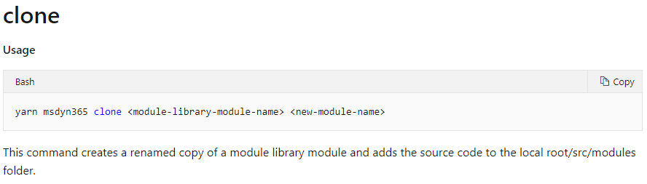

# Steps to consume and test the sample code.

**Option-1:** In case if the search-result-container module is not ejected in the repository you want to implement this feature, you can follow below steps to consume the attached sample code to implement and test this feature.

1. Unzip the attached code and save it to some location.
2. Copy files and folders under the same folder structure in your repository as it’s there in sample.zip.
3. Execute yarn on the root path of your repository.
4. Execute yarn build.
5. Execute yarn start.
6. Browse the configured product using pagemock using below sample URL.

https://localhost:4000/partnersite/page?mock=testmock

**Note**: check for the right *partnersite* in .env file of your repository and make a change in URL accordingly.

**Option-2:** If the search-result-container module is alreadyejected in the repository you want to implement this feature, you need to manually plugin the code from the attached sample files to the respective files. Please follow below file changes.

**Custom Search Result Container module file changes:** Need to modify below files in search result container module which was already ejected.

**Note:** Sample code contains search-result-container module cloned with new name as custom-search-result-container. So please map and refer the associated files for changing the code manually.

## Pagination and Infinite Scroll

* + - **Custom-search-result-container.definition.json (Module definition file)**

Introduce “infiniteScrollOnProducts” for the Switch

Import debounce from lodash



Add isLoadMore to the state.

Create a variable for current page number.

Add this enum

Set _currentPageNumber to 0 in the constructor.



Add below method in the constructor to trigger load more products on page scroll.

Set isLoadMore to false in the constructor.

Update “listPageState.currentPageNumber” with “this._currentPageNumber” in reaction expression.



Update the below code in reaction effect.

Add the below method.

In the definition.ext set the switch “infiniteScrollOnProducts” to true for infinite scroll



1. **Build the repository**:

Execute yarn build from command line interface on your repository after making above code changes.

1. **Test the code changes:**

Execute yarn start.

Browse the configured product using pagemock using below sample URL.

https://localhost:4000/partnersite/page?mock=testmock

**Note**: check for the right *partnersite* in .env file of your repository and make a change in URL accordingly.

**Note**: The sample code is tested on below package version:

